

**Experiment No.**

**3**

**Title:**

**F**

ile and P

rocess

handling using

system calls

**Batch:** B2 **Roll No: 16010420117** **Experiment No: 3**

**Aim:** Implementation of basic commands in Linux and write a program to show file and process handling using system call in Linux.

________________________________________________________________________

**Resources needed:**  Ubuntu 15.04 GNU.

# ________________________________________________________________________

**Theory:**

**Pre lab/Prior concepts:**

Study the commands given.

_______________________________________________________________________

**Activity:**

# Write a program to show file management and process management using system call. 

**___________________________________________________________ ____________**

**Results: Perform the activity task and attach the snapshots here.**

1. **Open, read, write and close for file management system call**

**Code**

#include <stdio.h>

#include <stdlib.h>

#include <string.h>

int main()

{

    FILE *ptr;

    char a;

    char filename[50];

    printf("Enter the name of file you wish to open: ");

    scanf("%s",filename);

    ptr = fopen(filename, "r");

    if (NULL == ptr)

    {

        printf("file can't be opened \n");

    }

    printf("content of this file are \n");

    do {

        a = fgetc(ptr);

        printf("%c", a);

    } while (a != EOF);

    fclose(ptr);

    return 0;

}

**Text file data**

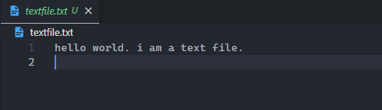

**Output**

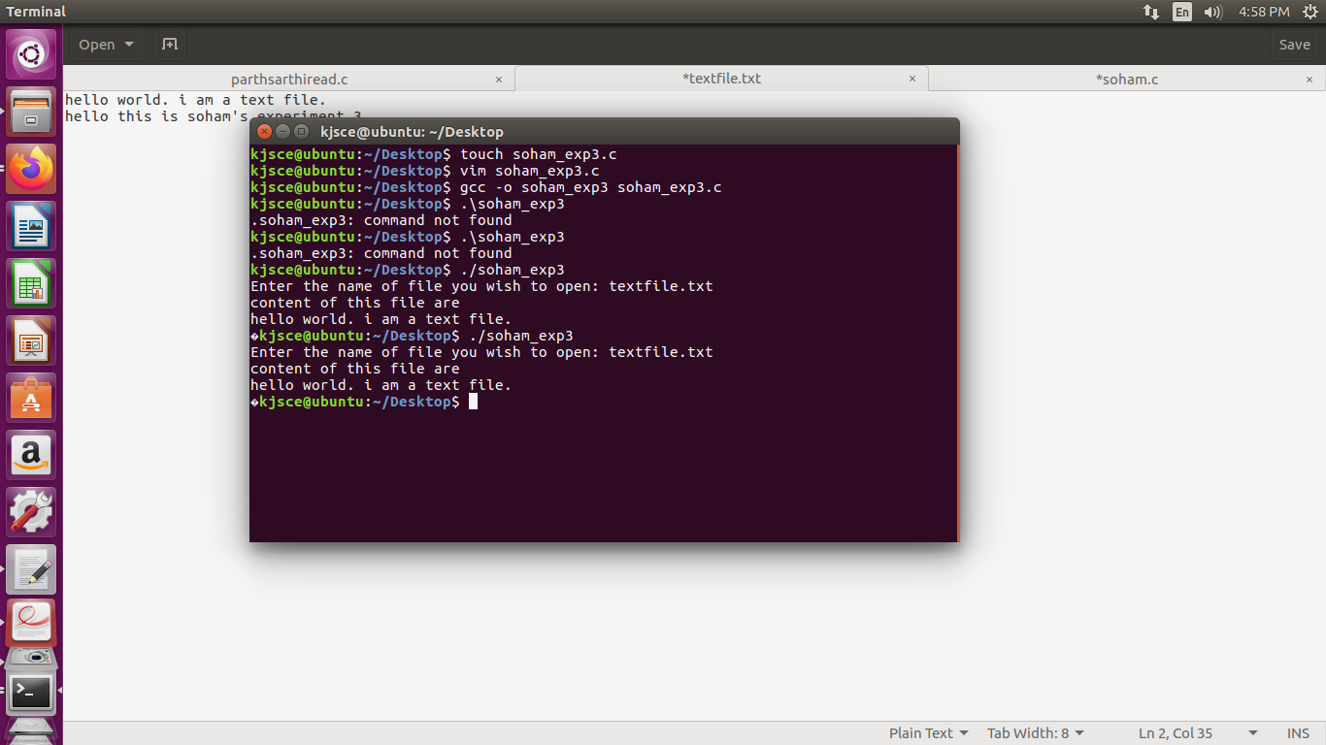

**The assignment submitted should be e- media saved as <Roll No_Batch No_Date>**



**File**

**must contain**

**on the top:**

**Name:**

**Roll No.**

**Exp No.**

**Batch:**

**Date:**

**Outcomes:**

**CO1:**

Understand basic structure of

modern operating system

**____**

**____________________________________________________________________**

**Conclusion:**

**Understanding the results how system calls are used for file and process**

**handling.**

**Grade: AA/AB/BB/BC/CC/CD/DD**

**Signature of faculty in-charge with date**

**_____________________________________________________________________** **References:**

**Books/ Journals/ Websites:**

1. RichardndEdition Blum edition, and Christine Wiley, 2012 Bresnahan, “Linux. Command Line & Shell Scripting”, II